Team TechOps

Using Deep Learning to Monitor Parking Spaces

Design Document

Table of Contents

Use Case Diagram 2

Class Diagram 3

State Chart 4

# Use Case Diagram

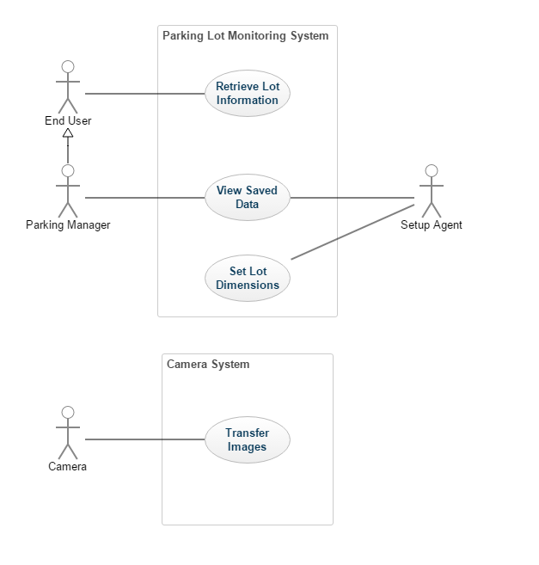

# Class Diagram

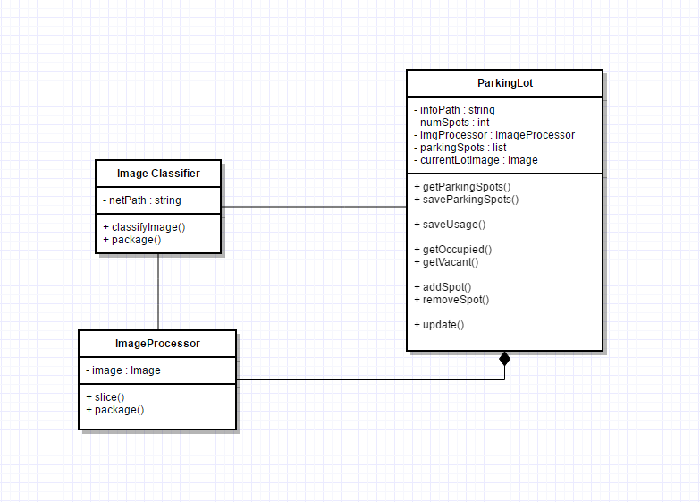

# State Chart

C:\Users\abates30\Desktop\initialumlstuff\State Chart.png